**SYNOPSIS**

**Report On**

**Real Time Weather App**

**In ReactJS**

**Submitted By**

**Akash Pal**

**(2000290140012 )**

**Akshay Singh**

**(2000290140014 )**

**Aviral Srivastava**

**(2000290140035)**

**Submitted in partial fulfilment of the**

**Requirements for the Degree of**

**MASTER OF COMPUTER APPLICATIONS**

**Under the Supervision of**

**Dr. Amit Kumar**

**Assistant Professor**



**Submitted to**

**Department Of Computer Applications**

**KIET Group of Institutions, Ghaziabad**

**Uttar Pradesh-201206**

**(May 2022)**

**ABSTRACT**

The report has been made in attempt to provide user with real time weather forecasting with 7 days in future forecasting. For making this project we have

studied various concepts related to the weather app and how different factors affect weather app. We also studied about various API Application Programming Interfaces that can be used to provide weather data in easier manner. The project aims at providing most details like humidity, air speed, and many other features.

The prediction of a weather can be used for future planning. Forecasting accuracy is the most important factor in selecting any forecasting methods. Research efforts in improving the accuracy of forecasting models are increasing since the last decade.

Weather forecasting is the attempt by meteorologists to predict the weather conditions at some future time and the weather conditions that may be expected. The climatic condition parameters are based on the temperature, wind, humidity, rainfall and size of data set.

**TABLE OF CONTENTS**

1. Introduction
2. Literature Review
3. Project / Research Objective
4. Project / Research Outcome
5. Proposed Time Duration

**INTRODUCTION**

**Weather forecasting** is the application of science and technology [to predict](https://en.wikipedia.org/wiki/Forecasting) the conditions of the [atmosphere](https://en.wikipedia.org/wiki/Earth's_atmosphere) for a given location and time. People have attempted to predict the weather informally for [millennia](https://en.wikipedia.org/wiki/Millennia) and formally since the 19th century. Weather forecasts are made by collecting quantitative data about the current state of the atmosphere, land, and ocean and using [meteorology](https://en.wikipedia.org/wiki/Meteorology) to project how the atmosphere will change at a given place.

Once calculated manually based mainly upon changes in [barometric pressure](https://en.wikipedia.org/wiki/Atmospheric_pressure), current weather conditions, and sky condition or cloud cover, weather forecasting now relies on [computer-based models](https://en.wikipedia.org/wiki/Numerical_weather_prediction) that take many atmospheric factors into account.

The inaccuracy of forecasting is due to the [chaotic](https://en.wikipedia.org/wiki/Chaos_theory) nature of the atmosphere, the massive computational power required to solve the equations that describe the atmosphere, the land, and the ocean, the error involved in measuring the initial conditions, and an incomplete understanding of atmospheric and related processes. Hence, forecasts become less accurate as the difference between current time and the time for which the forecast is being made (the *range* of the forecast) increases. The use of ensembles and model consensus help narrow the error and provide confidence level in the forecast.

**Literature Review**

Climatology and Weather Forecasting is important since it helps determine future climate expectations. Through the use of latitude, one can determine the likelihood of snow and hail reaching the surface. You can also be able to identify the thermal energy from the sun that is accessible to a region.

Climatology is the scientific study of climates, which is defined as the mean weather conditions over a period of time. A branch of study within atmospheric sciences, it also takes into account the variables and averages of short-term and long-term weather conditions.

Historical climatology focuses primarily on climate changes throughout history and the effects of the climate on people and events over time. Though both climatology and meteorology are areas of study that are considered branches of similar areas of study, climatology differs from meteorology because its focus is on averages of weather and climatic conditions over a long period of time. Meteorology focuses more on current weather conditions such as humidity, air pressure, and temperatures and forecasting the short-term weather conditions to come.

The mission of the Climatology and Weather Forecasting uses provides a forum for publishing new findings on Environmental principles and technology. Currently our primary research objective is to encourage and assist the development of better and faster measures of Environmental activity. In cases where we believe we can contribute directly, as opposed to through highlighting the work of others, we are producing our own measures of Climatology and Weather Forecasting.

**Project Objective**

The Objective of this project is to provide its users with the today’s weather forecast. It also include multiple pages that will contain the 5 days weather forecasting.

This forecasting will provide the data related to the humidity, temperature, maximum temperature, minimum temperature, wind pressure and lots more data is there.

When the project is opened, it ask for location and when allowed, then it takes latitude and longitude and then it gives the weather forecasting of that location.

There is also a search bar for searching the location and from that location, user can get that location’s weather.

When the user clicks on a buttons, a new page will be opened and on that page, user will have a completely new design with different number of card designs.

Each card will contain the future forecast of the that city that user have searched for.

**Project Outcome**

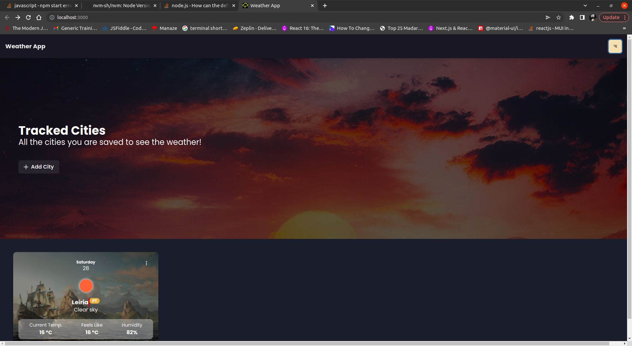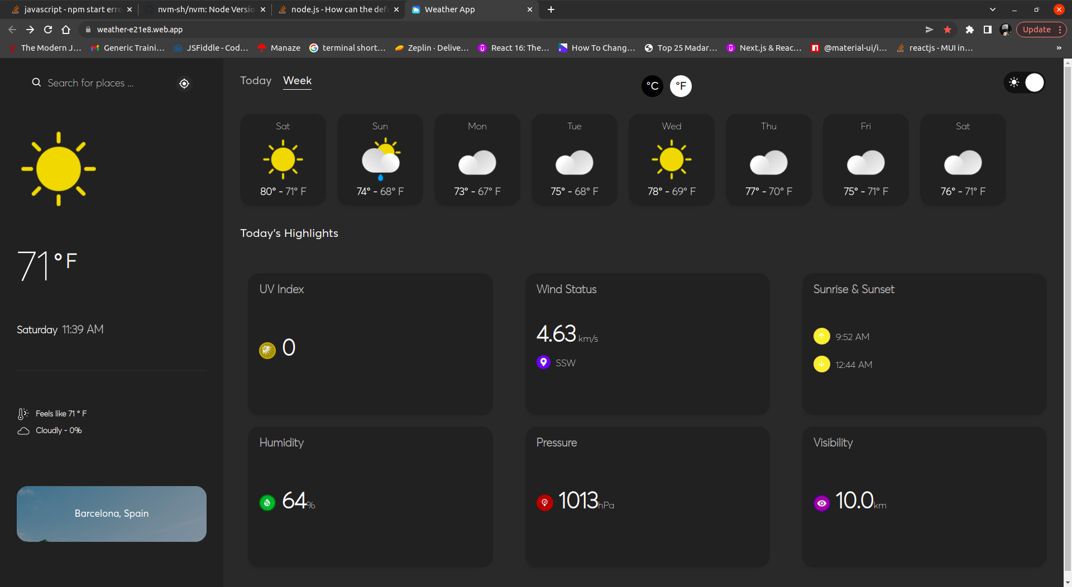

Project Duration

|  |  |  |  |  |  |  |
| --- | --- | --- | --- | --- | --- | --- |
| **Procedures​​** | **Week 1​​** | **Week 2​​** | **Week 3​​** | **Week 4​​** | **Week 5​​** | **Week 6​​** |
| Requirement Analysis​​ |  | ​​ | ​​ | ​​ | ​​ | ​​ |
| Design​​ | ​​ |  | ​​ | ​​ | ​​ | ​​ |
| Implementation (Coding)​​ | ​​ | ​​ |  |  | ​​ | ​​ |
| Testing​​ | ​​ | ​​ | ​​ | ​​ |  | ​​ |
| Maintenance​​ | ​​ | ​​ | ​​ | ​​ | ​​ |  |